**PROJECT TITLE:**

|  |
| --- |
| AADHAR CARD REGISTRATION AND VIEWING DETAILS USING ASP.NET AND SQL SERVER |

**AIM:**

To code a program using asp.net to register and view the details of aadhar using asp.net and sql server.

**LOGIN FORM CODE:**

using System;

using System.Collections.Generic;

using System.Linq;

using System.Web;

using System.Web.UI;

using System.Web.UI.WebControls;

public partial class _Default : System.Web.UI.Page

{

protected void Page_Load(object sender, EventArgs e)

{

}

protected void Login1_Authenticate(object sender, AuthenticateEventArgs e)

{

Response.Redirect("Default4.aspx");

}

}

**LOGIN FORM DESIGN:**

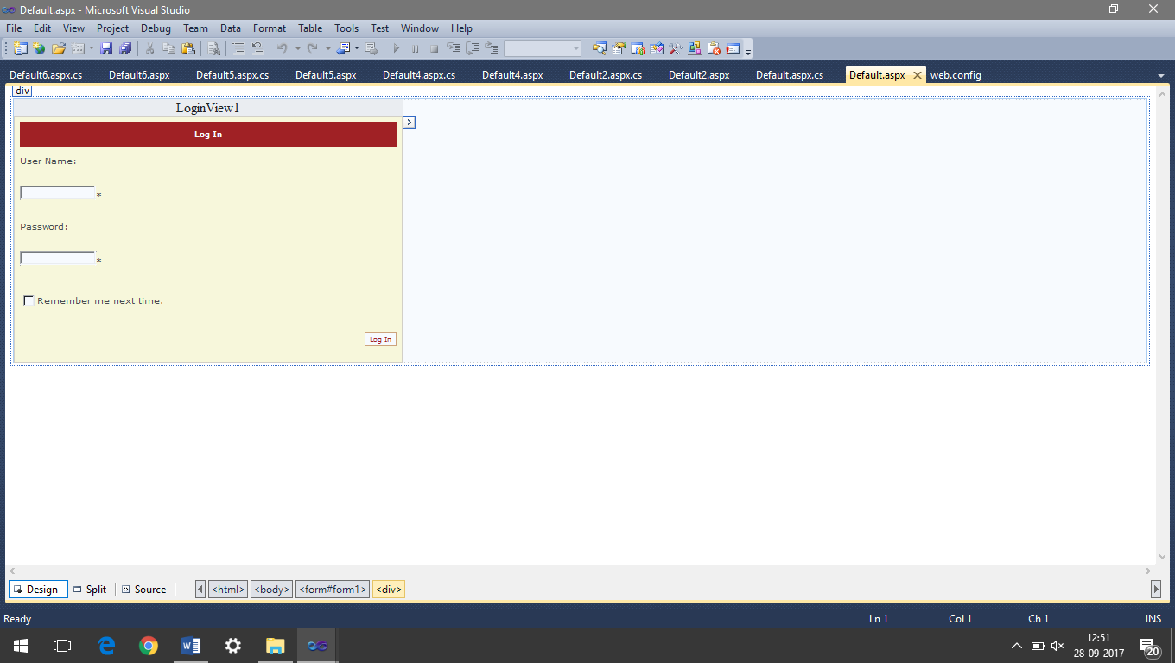

**REGISTER AADHAR DETAILS CODE**:

using System;

using System.Collections.Generic;

using System.Linq;

using System.Web;

using System.Web.UI;

using System.Web.UI.WebControls;

using System.Data;

using System.Data.SqlClient;

using System.Configuration;

public partial class Default2 : System.Web.UI.Page

{

protected void Page_Load(object sender, EventArgs e)

{

}

protected void Button1_Click(object sender, EventArgs e)

{

SqlConnection conn = new SqlConnection(ConfigurationManager.ConnectionStrings["aadharConnectionString"].ConnectionString);

SqlCommand cmd = new SqlCommand("Insert Into aadhardetails (aadharno,name,dob,gender,address) VALUES (@no,@na,@dob,@gen,@add)",conn);

cmd.CommandType=CommandType.Text;

cmd.Parameters.AddWithValue("@no",TextBox1.Text);

cmd.Parameters.AddWithValue("@na",TextBox2.Text);

cmd.Parameters.AddWithValue("@dob",TextBox3.Text);

cmd.Parameters.AddWithValue("@gen",DropDownList1.Text);

cmd.Parameters.AddWithValue("@add",TextBox4.Text);

conn.Open();

cmd.ExecuteNonQuery();

Response.Redirect("Default3.aspx");

}

protected void Menu1_MenuItemClick(object sender, MenuEventArgs e)

{

Response.Redirect("Default4.aspx");

}

}

**REGISTER AADHAR DETAILS FORM DESIGN:**

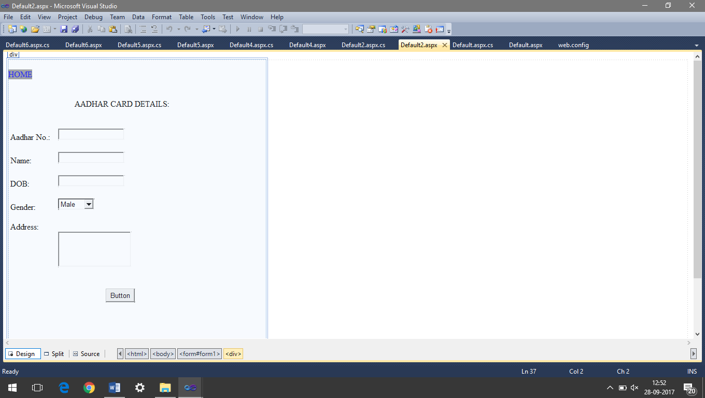

**LOGIN AUTHENTICATION CODE:**

using System;

using System.Collections.Generic;

using System.Linq;

using System.Web;

using System.Web.UI;

using System.Web.UI.WebControls;

public partial class Default4 : System.Web.UI.Page

{

protected void Page_Load(object sender, EventArgs e)

{

}

protected void LinkButton1_Click(object sender, EventArgs e)

{

Response.Redirect("Default2.aspx");

}

protected void LinkButton3_Click(object sender, EventArgs e)

{

Response.Redirect("Default6.aspx");

}

protected void LinkButton4_Click(object sender, EventArgs e)

{

Response.Redirect("Default.aspx");

}

}

**LOGIN AUTHENTICATION FORM DESIGN:**

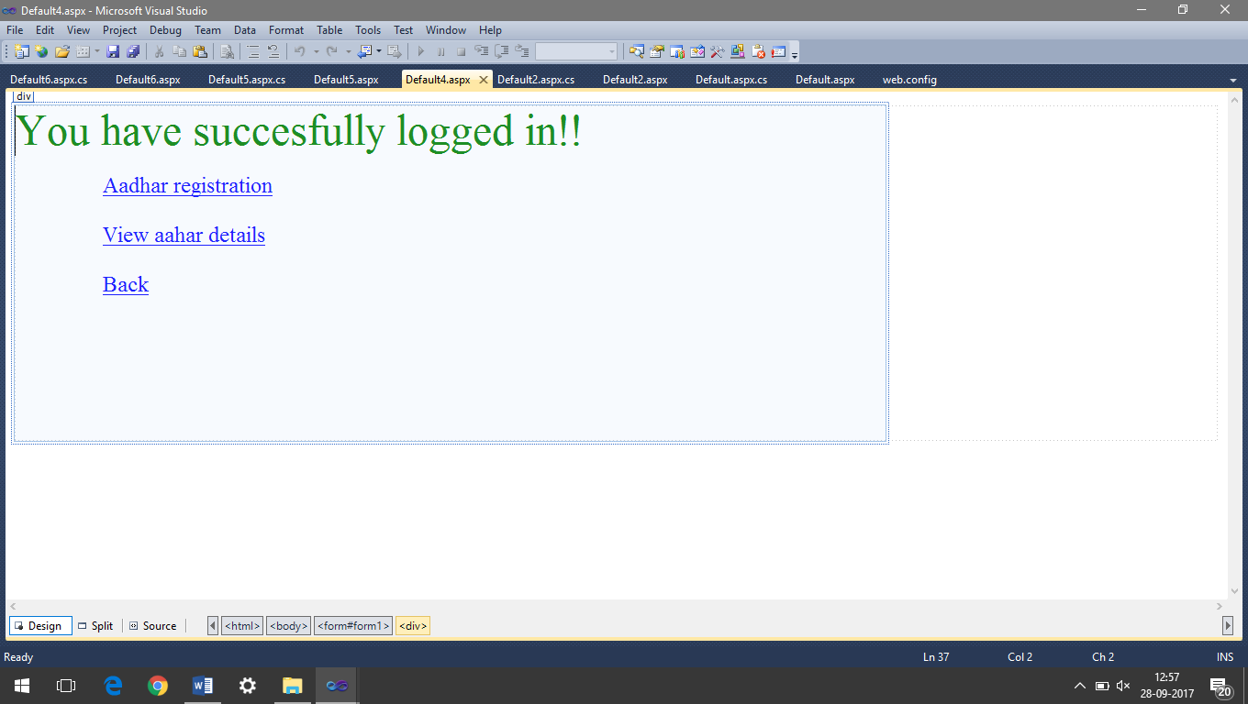

**VIEW AADHAR DETAILS CODE:**

using System;

using System.Collections.Generic;

using System.Linq;

using System.Web;

using System.Web.UI;

using System.Web.UI.WebControls;

using System.Data;

using System.Data.SqlClient;

using System.Configuration;

public partial class Default6 : System.Web.UI.Page

{

SqlConnection conn = new SqlConnection(ConfigurationManager.ConnectionStrings["aadharConnectionString"].ConnectionString);

protected void Page_Load(object sender, EventArgs e)

{

}

protected void Button1_Click(object sender, EventArgs e)

{

string str;

conn.Open();

str = "select * from aadhardetails Where aadharno='" + TextBox6.Text + "'";

SqlCommand aadcom = new SqlCommand(str, conn);

SqlDataReader reader;

reader = aadcom.ExecuteReader();

while (reader.Read())

{

TextBox1.Text = reader["aadharno"].ToString();

TextBox2.Text = reader["name"].ToString();

TextBox3.Text = reader["dob"].ToString();

TextBox5.Text = reader["gender"].ToString();

TextBox4.Text = reader["address"].ToString();

}

conn.Close();

}

}

**VIEW AADHAR DETAILS FORM DESIGN:**

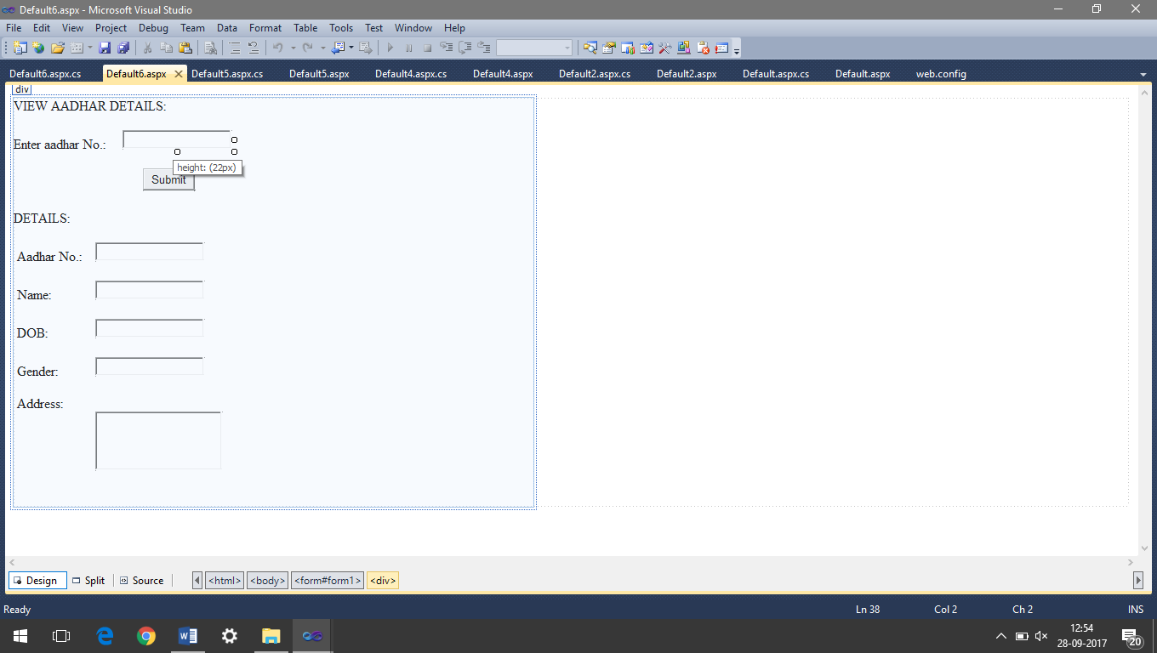

**OUTPUT:**

**CREATE USER:**

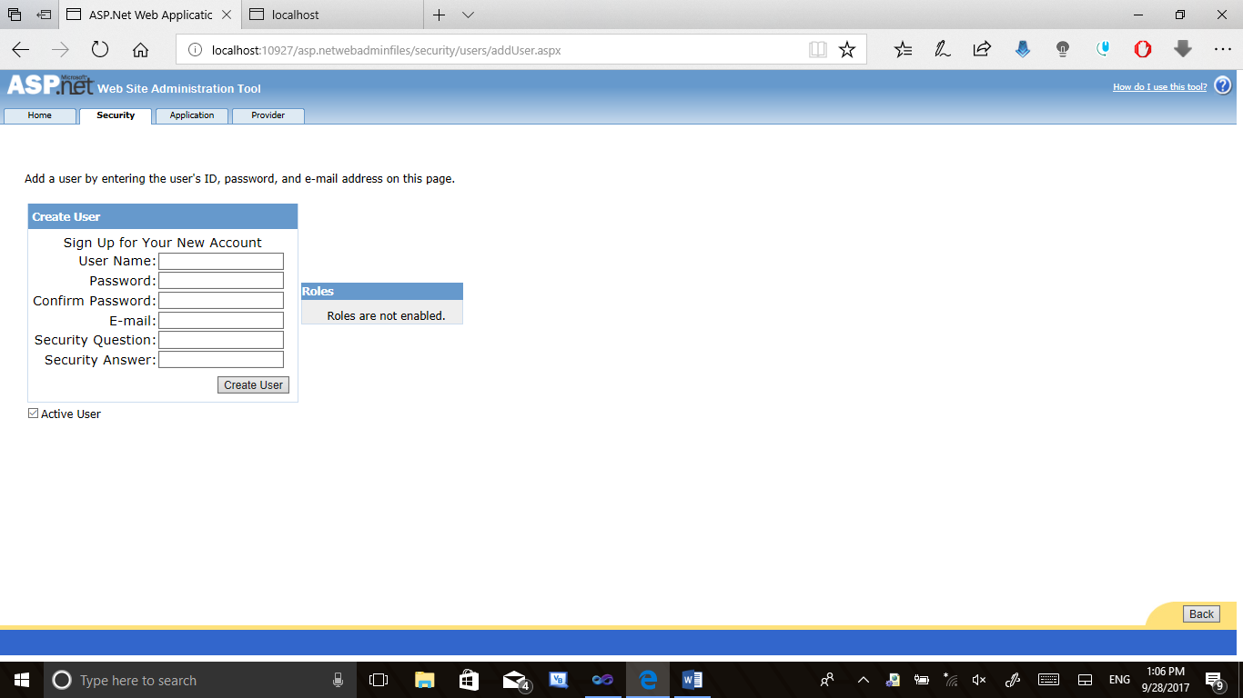

**LOGIN:**

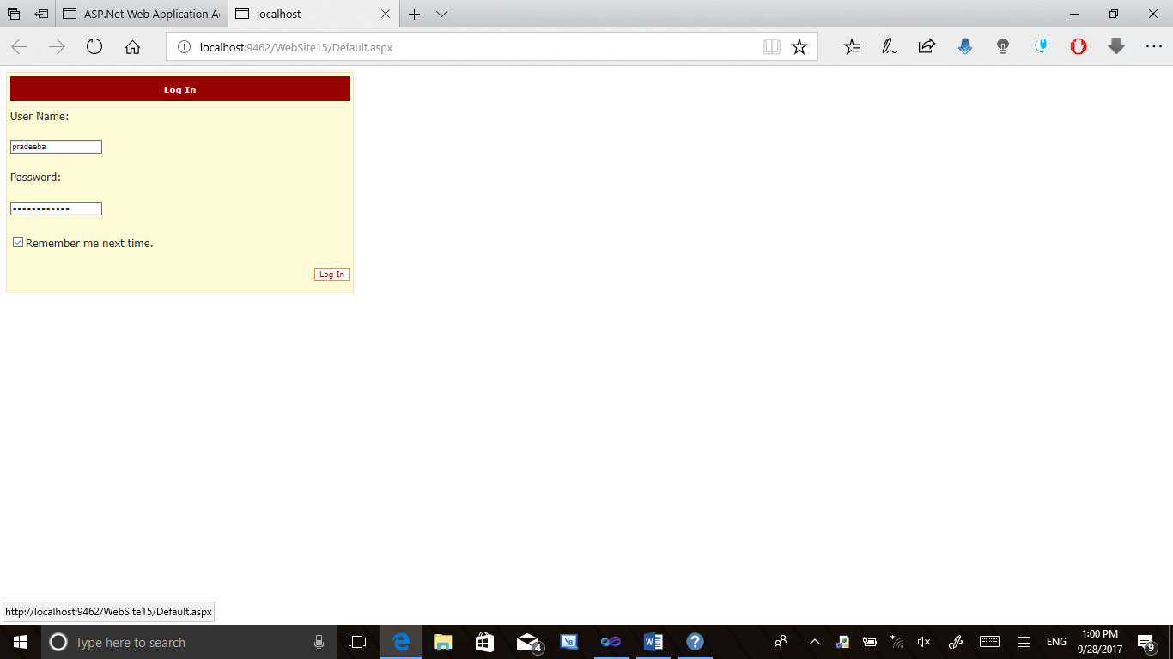

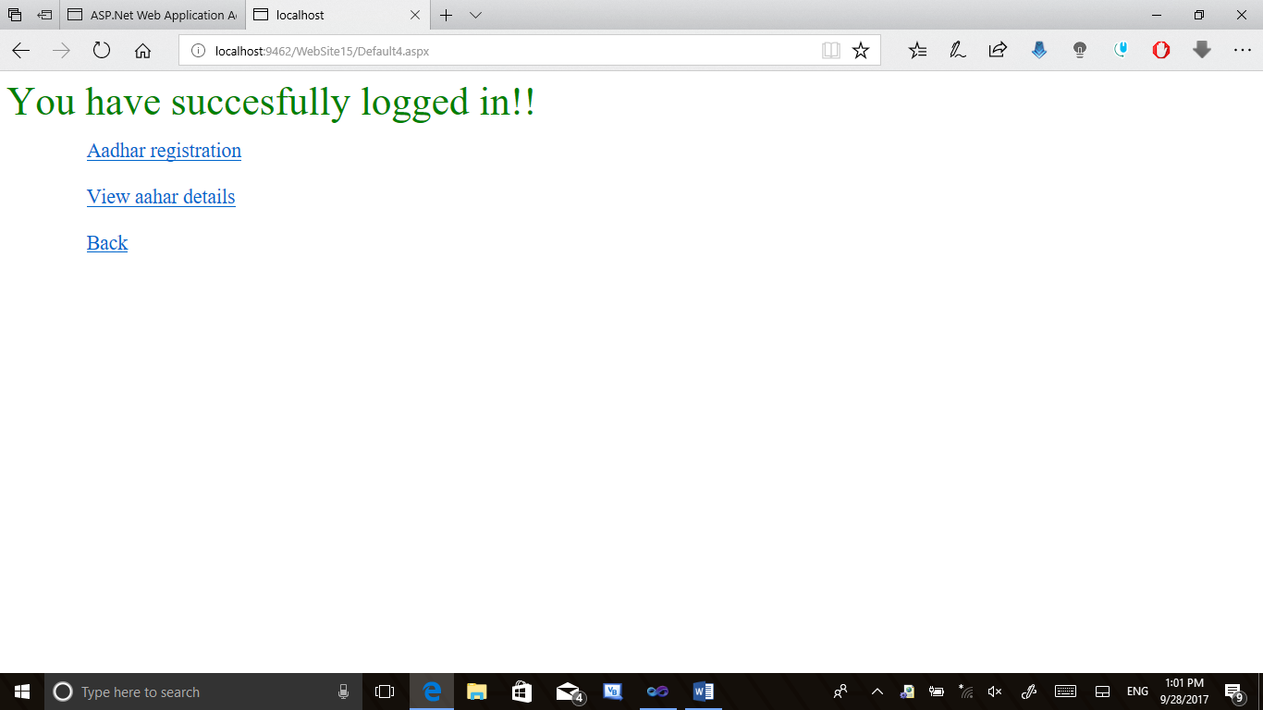

REGISTRATION:

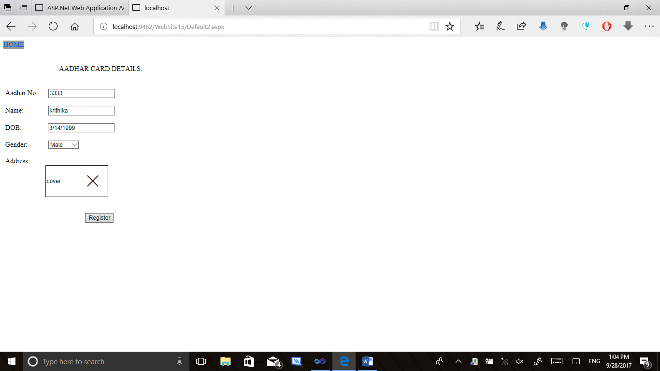

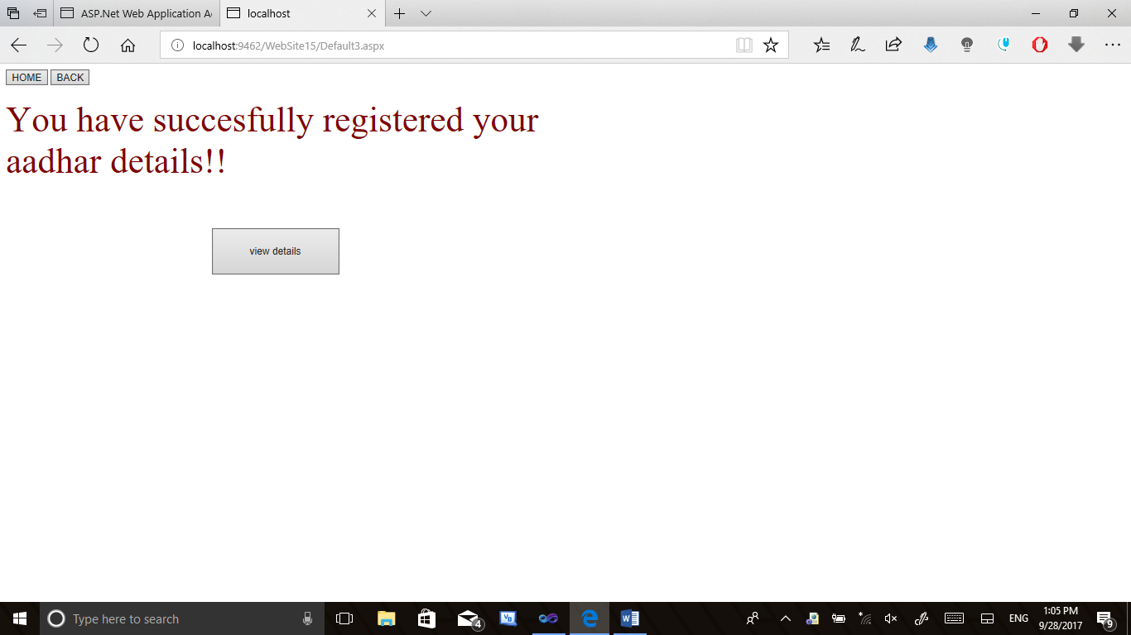

**VIEW DETAILS:**

